1) Generate feature file for the following applications

- redbus.in (search)

- <https://login.salesforce.com/>

**Generate feature file**

**Redbus.in(search)**

Feature: Book a Bus Ticket

Scenario Outline: Select source, destination, and travel date

Given I open the bus ticket booking page

When I click the source field

And I select "<source>" as the source location

And I click the destination field

And I select "<destination>" as the destination location

And I click the travel date button

Then I should see the date "<date>" selected

Examples:

| source | destination | date |

| "Medavakkam" | "Bathalagundu" | "Today" |

| "Mylapore" | "Dindigul" | "Today" |

| "Tambaram" | "Theni" | "Today" |

| "Chengalpattu" | "Madurai" | "Today" |

<https://login.salesforce.com/>

Feature: Login to Application

Scenario Outline: Successful login with valid credentials

Given I open the login page

When I type "<username>" into the Username field

And I type "<password>" into the Password field

And I check the Remember me checkbox

And I click the Log In button

Then I should be logged in successfully

Examples:

| username | password |

| "ravi.kumar@chennai.com" | "M@yur123$" |

| "suresh.menon@bangalore.com"| "B@ngalore1"|

Scenario Outline: Unsuccessful login with invalid credentials

Given I open the login page

When I type "<username>" into the Username field

And I type "<password>" into the Password field

And I click the Log In button

Then I should see an error message indicating invalid credentials

Examples:

| username | password |

| "invalid.user@hyd.com" | "WrongPass1"|

| "test.user@pune.com" | "123456" |

Scenario: Remember me functionality

Given I open the login page

When I type "suresh.menon@bangalore.com" into the Username field

And I type "B@ngalore1" into the Password field

And I check the Remember me checkbox

And I click the Log In button

Then I should be logged in successfully

And My session should persist after closing the browser

Action 2 : Add a new groq model and confirm it is working

Hint: add model id and label in popup.js + close / reopen

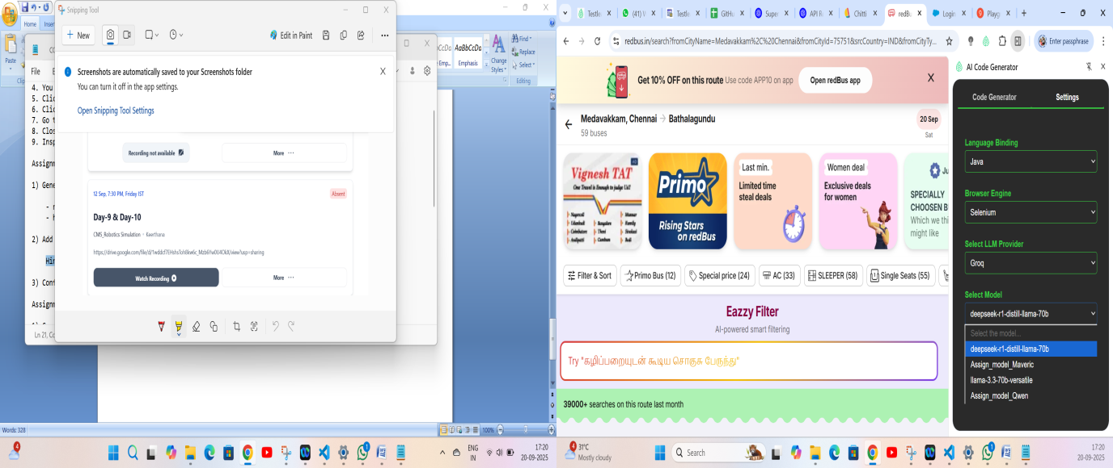

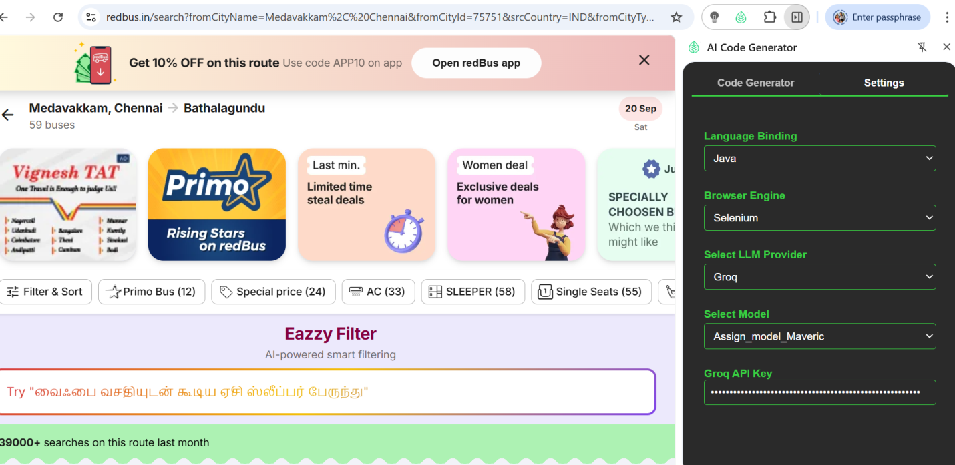

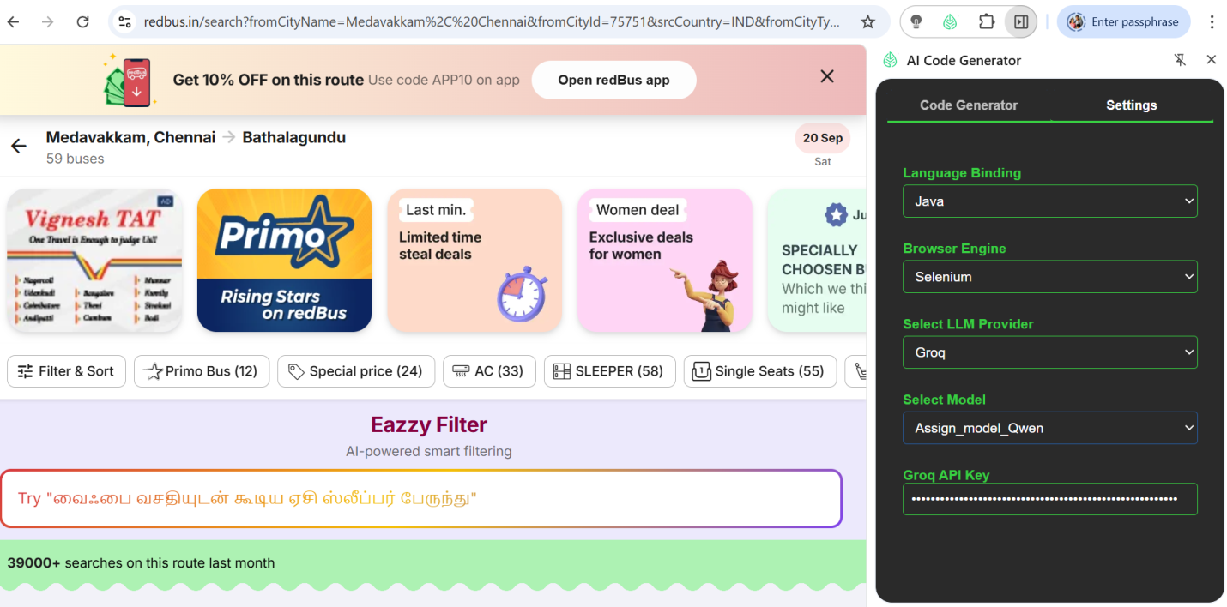

3) Confirm 1.1 is working - Selecting Maveric Model ;

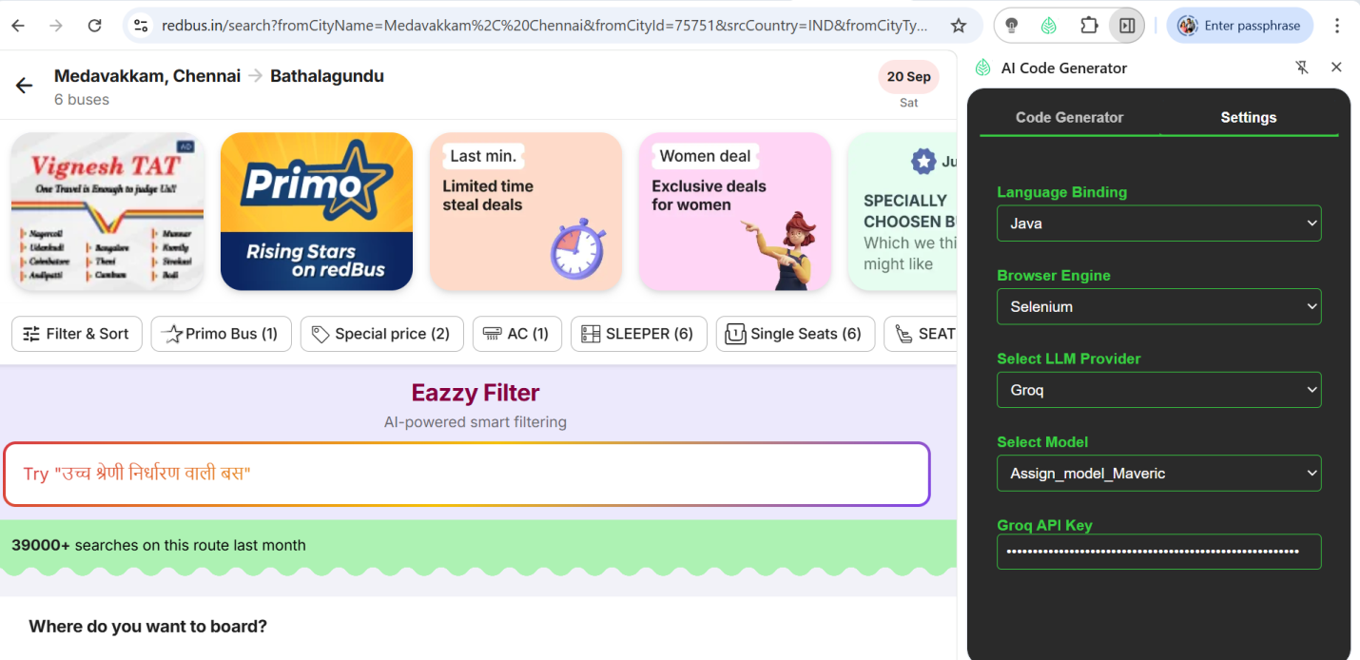

Feature: Bus Booking Journey

Scenario Outline: Successful bus booking with valid route and date

Given I open the bus booking page

When I select "<from>" as the source city

And I select "<to>" as the destination city

And I select "<date>" as the date of journey

Then I should see the available buses for the selected route and date

Examples:

| from | to | date |

| Medavakkam | Bathalagundu | 20 Sep, 2025 |

| Tambaram | Kumbakonam | 21 Sep, 2025 |

| Velachery | Thanjavur | 22 Sep, 2025 |

| Guindy | Madurai | 23 Sep, 2025 |

| Adyar | Tirunelveli | 24 Sep, 2025 |

Scenario Outline: Verify date selection for bus booking

Given I open the bus booking page

When I click on the date of journey field

And I select "<date>" from the calendar

Then the selected date should be "<date>"

Examples:

| date |

| 20 Sep, 2025 |

| 21 Sep, 2025 |

| 22 Sep, 2025 |

| 23 Sep, 2025 |

| 24 Sep, 2025 |

Feature: Login to Application

Scenario Outline: Successful login with valid credentials

Given I open the login page

When I type "<username>" into the Username field

And I type "<password>" into the Password field

And I click the Login button

Then I should be logged in successfully

Examples:

| username | password |

| "kavitha@example.com" | "Kavitha123" |

| "suresh.chennai@example.com" | "Suresh@123" |

Scenario Outline: Login with different combinations

Given I open the login page

When I type "<username>" into the Username field

And I type "<password>" into the Password field

And I check the Remember me checkbox

And I click the Login button

Then I should be logged in successfully

Examples:

| username | password |

| "ramesh.hyderabad@example.com" | "Ramesh@123" |

| "priya.bangalore@example.com" | "Priya123" |